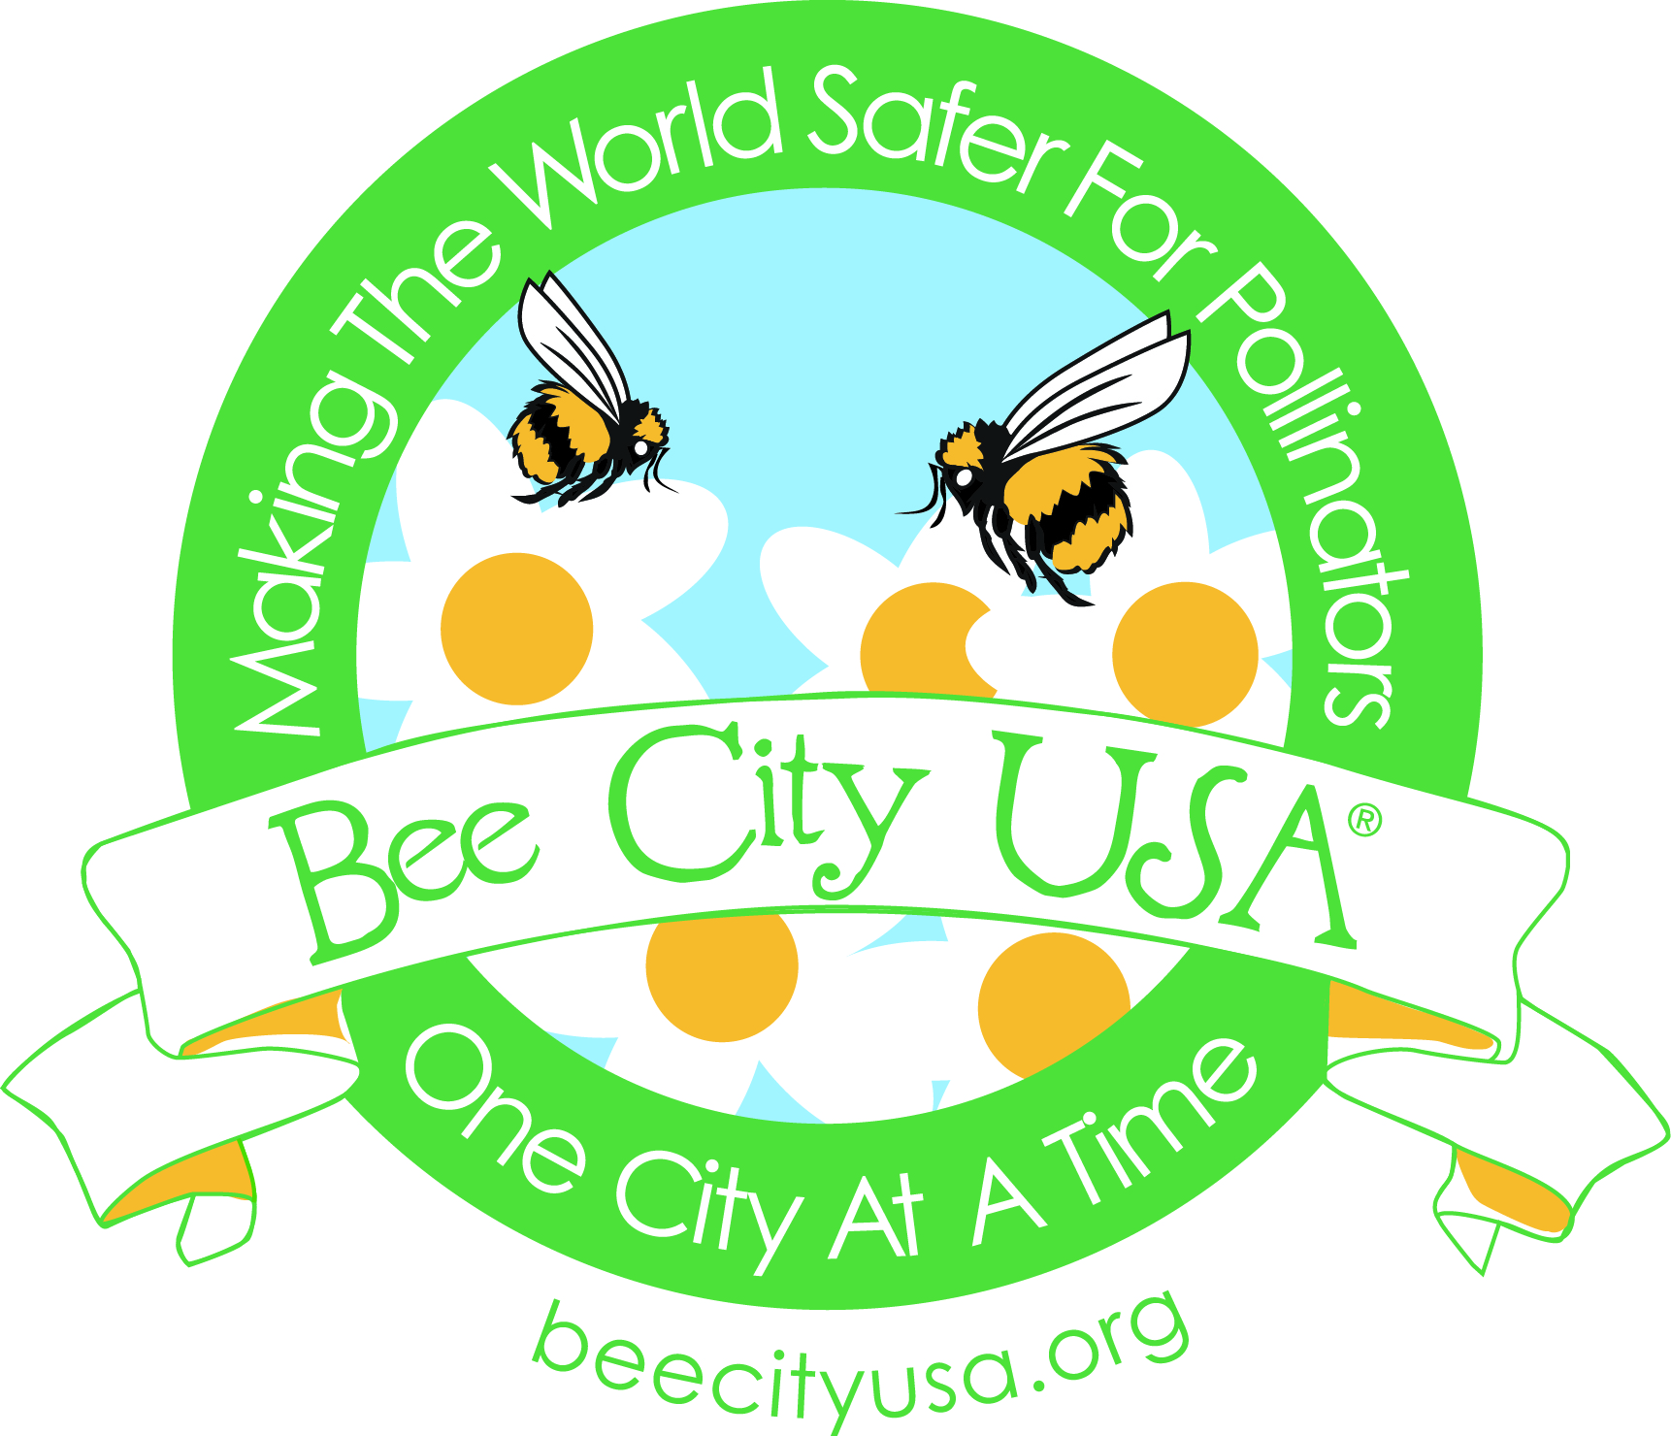 | Contact: Phyllis Stiles, Director  Bee City USA  beecityusa@gmail.com  828-545-4282

For Immediate Release
September 2, 2016

Bee City USA® Calls for Conversations Between Local Government Agencies and Beekeeping Chapters on Mosquito Abatement Plans

Tragically, millions of honey bees in Summerville, South Carolina, were found dead after Dorchester County ordered aerial spraying for mosquitoes between 6:30 and 8:30 last Sunday morning. The pesticide was the organophosphate Naled, used for mosquito abatement since the 1950s. Facing elevated losses and causing concern at the highest levels of government, honeybees and other pollinators are responsible for the reproduction of more than three-quarters of the world’s plant species and are vital to food security.

According to the Centers for Disease Control (CDC), “Spraying Naled can kill bees outside of their hives at the time of spraying; therefore, spraying is limited to dawn or dusk when bees are inside their hives. Because Naled breaks down quickly, it does not pose a risk to the honey bee populations…. For additional protection, urban beekeepers inside the spray zone can cover their hives when spraying occurs.” (http://www.cdc.gov/zika/vector/aerial-spraying.html) However, Dorchester County failed to directly notify beekeepers of plans to spray.

Bee City USA®, a national organization that galvanizes communities to sustain pollinators by providing them with healthy habitat, rich in a variety of native plants and free to nearly free of pesticides, encourages mosquito abatement districts across the country to provide beekeepers with ample notice of planned spraying so they can protect their hives as much as possible by covering them or moving them to a non-spray zone. By the same token, we encourage beekeeping chapters to meet with county officials in charge of vector control as soon as possible and each year to discuss mosquito control plans that protect pollinator health, and in the event of bee kills, how beekeepers will be compensated.

The mounds of dead bees near their hives in Summerville had beekeepers who were checking on them, but what about the other millions of wild non-honey bees living solitary lives with no keepers? Unlike honey bees, they are active early in the morning precisely when spraying is recommended “while pollinators are least active.” And what about the millions of moths, most of which are active at night when spraying is recommended?

Ironically, according to Zika Virus Net http://www.zikavirusnet.com/aedes-aegypti.html, the mosquitoes that may carry the Zika virus (Aedes aegypti) are a day-biting mosquito, most active during daylight, for approximately two hours before sunrise and several hours before sunset.” Furthermore, it “rests indoors, in closets and other dark spaces. Outside, they rest where it is cool and shaded. Unlike mosquitoes that breed in standing temporary pools of water, Aedes aegypti is adapted to breed around human dwellings and prefers to lay its eggs in clean water which contains no other living species.” Lastly, and perhaps most importantly, unless they are carried by the wind, mosquitoes generally are not strong fliers and generally do not travel more than a few hundred feet from where they pupated to become adults. Even though the CDC and researchers say larvicide the most effective mosquito abatement strategy, communities continue using aerial sprays like Naled to target flying adult mosquitoes rather than their larvae.

In light of the fact that the scientific community is just now learning about this mosquito’s biology and behavior, we encourage much more public education, prevention efforts, and larval control before mounting widespread ground or aerial spraying campaigns. Indeed, according to Dr. David Pimentel, former professor of entomology at Cornell University, such spraying delivers less than 0.0001% of the insecticide to the target mosquitoes, and instead, releases 99.999% into the environment generally, threatening public health and potentially causing other environmental problems.

The professionals responsible for public safety bear a very heavy burden. Mosquito-borne viruses like Zika, West Nile, Dengue and Chikungunya are threats to human health. While West Nile virus has spread across the United States and Canada and numerous cases of Chikungunya have been acquired in Florida and Texas, to date there have been no reported cases of Dengue contracted in the continental United States and, so far, the CDC has only reported cases of locally-acquired Zika in Miami, Florida.

Unfortunately, according to Beyond Pesticides, “The more insecticides are relied upon to control mosquito populations, the quicker mosquitoes develop resistance to the insecticides.” That being said, Bee City USA is happy that in addition to the CDC’s advice about killing mosquitoes with insecticides, the CDC goes to great lengths to advise people to take precautions to prevent mosquito bites with the help of protective clothing, window and door screens, and repellents.

Experts generally agree that aerial spraying is at best only a temporary measure, which will not eliminate the problem. Moreover, aerial spraying may kill natural mosquito predators like dragonflies and damselflies, in addition to countless species of beneficial insects, including pollinators. Beyond Pesticides recommends, “To combat mosquito resistance, the dependency on chemical control must be addressed and lead to more sustainable methods, which include habitat modification, improved sanitation, and use of natural controls.”

For more information, see Beyond Pesticide’s article on Mosquito Control and Pollinator Health (http://www.beyondpesticides.org/assets/media/documents/Summer2016MosquitosAndPollinators.pdf), and Mosquito Management and Insect-Borne Diseases webpage (http://www.beyondpesticides.org/programs/mosquitos-and-insect-borne-diseases/overview).

Bee City USA® is a nonprofit national organization that galvanizes communities to sustain pollinators, responsible for the reproduction of three-quarters of the world's plant species, by providing them with healthy habitat, rich in a variety of native plants and free to nearly free of pesticides. During the past few years, there have been calls to action both nationally and internationally to reverse pollinator declines. Both thinking globally and acting locally, Bee City USA offers a positive vision, which encourages individual efforts while facilitating creative, constructive community partnerships. Recognizing that we rely on pollinators (bees, butterflies, hummingbirds, flies, moths, beetles, etc.) for one in every three bites we eat, the program seeks to make the world safer for pollinators, one city at a time. Bee City USA launched in Asheville in June 2012. As of September 2016, we have certified 30 cities in 19 states as Bee City USA affiliates. In April 2015, we launched the companion program, Bee Campus USA for educational institutions and currently have certified 13 affiliates in 9 states. We helped Toronto launch Bee City Canada in spring 2016. Learn more at beecityusa.org.

